Leetcode_174_DungeonGame_地牢游戏_Hard

# Leetcode_174_DungeonGame_地牢游戏_Hard

## 题目介绍

/**

* 难度：Hard

* https://leetcode.com/problems/dungeon-game/description/

*

* The demons had captured the princess (P) and imprisoned her

* in the bottom-right corner of a dungeon.

* The dungeon consists of M x N rooms laid out in a 2D grid.

* Our valiant knight (K) was initially positioned in the top-left room

* and must fight his way through the dungeon to rescue the princess.

* The knight has an initial health point represented by a positive integer.

* If at any point his health point drops to 0 or below, he dies immediately.

*

* Some of the rooms are guarded by demons, so the knight loses health (negative integers)

* upon entering these rooms; other rooms are either empty (0's) or contain magic orbs

* that increase the knight's health (positive integers).

*

* In order to reach the princess as quickly as possible, the knight decides to move

* only rightward or downward in each step.

* Write a function to determine the knight's minimum initial health

* so that he is able to rescue the princess.

* For example, given the dungeon below, the initial health of the knight must be

* at least 7 if he follows the optimal path RIGHT-> RIGHT -> DOWN -> DOWN.

*-2 (K) -3 3

* -5 -10 1

* 10 30 -5 (P)

* Note:

* The knight's health has no upper bound.

* Any room can contain threats or power-ups,

* even the first room the knight enters and the bottom-right room

* where the princess is imprisoned.

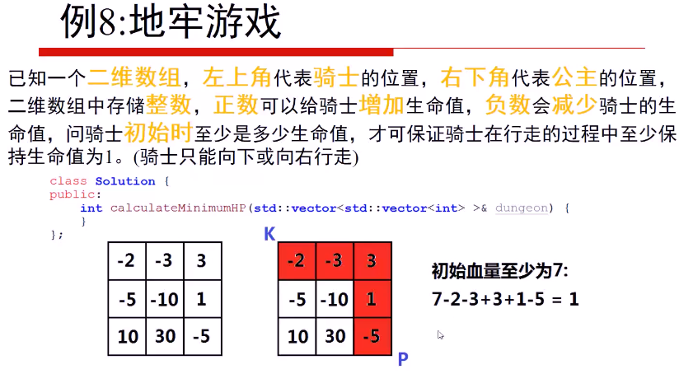

## 思路分析

动态规划思想：

* 思路分析：动态规划思想。

* 从右下向左上推进。

* dp[i][j]表示到达当前点之前至少需要的血量值；

* 因为血量至少是1才表示存活，因此到达该点至少需要血量值1；

* 又当前消耗可能为负值也可能为正值，但是无论如何，加上该方格的血量，

* 最后只是要大于等于1；即终点方格的dp[i][j]=max{1,1-dungeon[i][j]};

* 如终点方格为-5，这时到达该方格前至少需要血量为1-(-5)=6;

* 终点方格为5，这时到达该方格前至少需要血量max{1,1-5}=1;(因为小于1表示已死亡)

* 状态转移方程：

* dp[i][j] = max{1,min(dp[i][j+1],dp[i+1][j])}

* 初始化：终点dp[rows-1][columns-1]、最后一行和最后一列

* dp[rows-1][columns-1] = max{1,1-dungeon[i][j]};

* dp[rows-1][j] = max{1,dp[rows-1][j+1]-dungeon[i][j]};

* dp[i][columns-1] = max{1,dp[i+1][columns-1]-dungeon[i][j]};

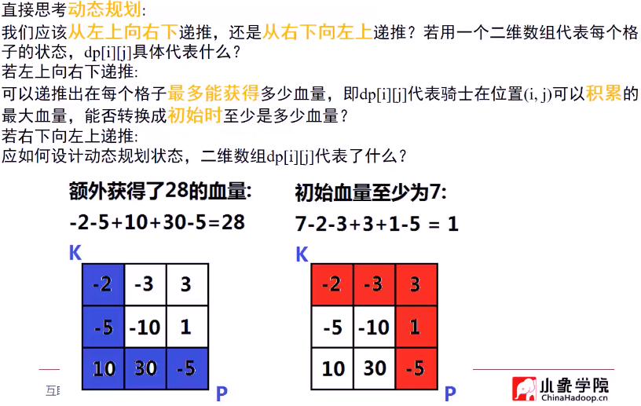

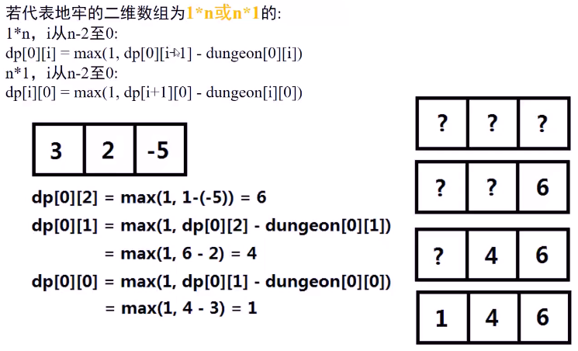

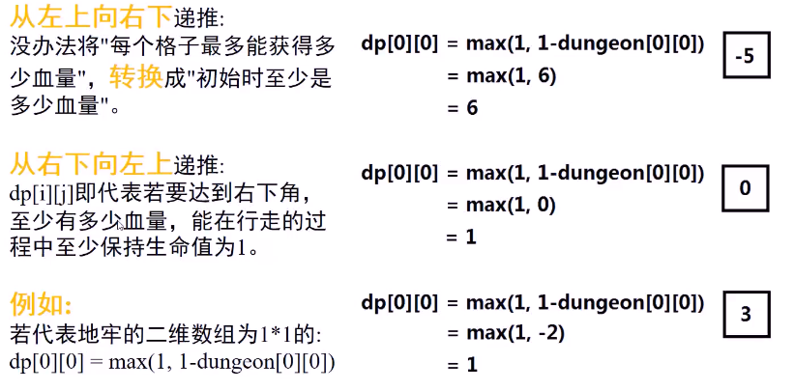

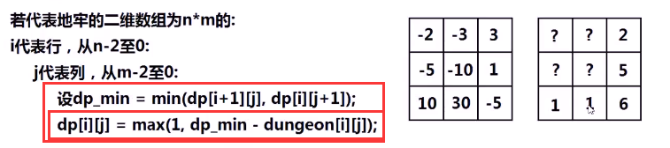

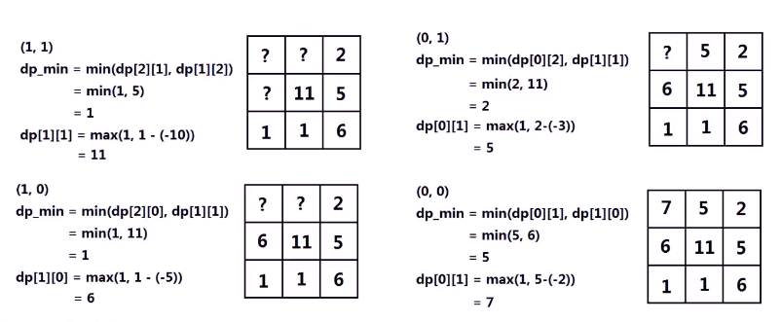

## Java代码

public int calculateMinimumHP(int[][] dungeon) {

if(dungeon == null||dungeon.length == 0) return 0;

int rows = dungeon.length,columns = dungeon[0].length;

//创建dp

int[][] dp = new int[rows][columns];

//初始化

**dp[rows-1][columns-1] = Math.max(1,1-dungeon[rows-1][columns-1]);**

for(int i = rows-2;i >= 0;i--)

**dp[i][columns-1] = Math.max(1,dp[i+1][columns-1]-dungeon[i][columns-1]);**

for(int j = columns-2;j >= 0;j--)

**dp[rows-1][j] = Math.max(1,dp[rows-1][j+1]-dungeon[rows-1][j]);**

//开始执行

for(int i = rows-2;i >= 0;i--){

for(int j = columns-2;j >= 0;j--){

**dp[i][j] = Math.max(1,Math.min(dp[i+1][j],dp[i][j+1])-dungeon[i][j]);**

}

}

return dp[0][0];

}

